(Your Business Name Here) – Safe Work Procedure

RIDE ON MOWER

DO NOT use this machine unless you have been instructed
in its safe use and operation and have been given permission

PERSONAL PROTECTIVE EQUIPMENT

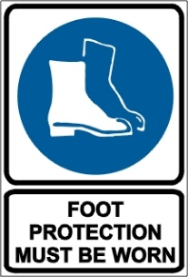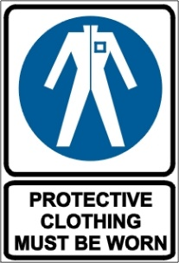

PRE-OPERATIONAL SAFETY CHECKS
- Locate and ensure you are familiar with all machine operations and controls.
- Ensure all guards are fitted, secure and functional. Do not operate if guards are missing or faulty.
- Ensure that seat belt, if fitted, is in sound condition.
- Ensure cutting blades are sharp, secure and in good condition.
- Ensure any pneumatic and hydraulic mechanisms are in sound condition.
- Ensure all electrical switches (including dead mans switch if fitted) are functioning.

OPERATIONAL SAFETY CHECKS
- Be sure the transmission is out of gear and the mower blade clutch disengaged before starting.
- Keep clear of moving machine parts.
- Drive at speed slow enough to keep control over unexpected hazards.
- Travel up/down slopes rather than across, taking extra care when ascending or descending steep slopes.
- Take care when refuelling to avoid spilling fuel onto hot motor or exhaust.
- Before making adjustments, bring the machine to a complete standstill and isolate.
- Watch for ejected material. Ensure no person or animal is endangered when operating equipment.

ENDING OPERATIONS
- Park on even ground.
- Stop the ride on mower and shift the gear selector to park position.
- Raise and secure the cutting blades.
- Lock the parking brake.
- Stop the engine and remove the keys.

CLEANING UP
- Remove any foreign material from in and around engine and catcher parts.
- Keep the work area or implement shed in a safe, clean and tidy condition.

POTENTIAL HAZARDS AND INJURIES
- Rapidly rotating cutting blades.
- Noise.
- Eye injuries.
- Ejected material and flying debris.

DON’T
- Do not use faulty equipment. Report suspect machinery immediately.
- Never carry passengers.

This safe work procedure does not necessarily cover all possible hazards associated with this equipment and should be used in conjunction with other references.
It is designed as a guide to be used to compliment training and as a reminder to users prior to equipment use.

ALWAYS refer to the manufacturer’s instructions when writing your own safe work procedure.

