
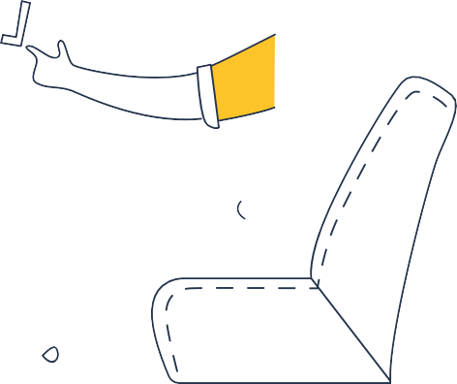



Resource

 Step 4: Improve

Gathering Worker Feedback

How to use this template
After introducing actions to improve your workplace, it is important to regularly check in with workers to get their feedback. This can help you:
- understand what is working well
- identify areas that still need improvement
- let workers know that their wellbeing is important to you
- meet your legal obligation to consult with workers about health and safety matters.
This template includes feedback questions (in the form of statements) for you to ask about the changes you have made. These are followed by open-ended questions to gather extra feedback and ideas for the workplace. Where possible, workers should be able to provide feedback confidentially or anonymously. You should also make it clear that providing feedback is optional, and there are no consequences if they do not want to take partin the survey.
For more information and guidance, please see www. worksafe.tas.gov.au/mindsmatter


An initiative of the WorkCover Board Tasmania, delivered by WorkSafe Tasmania



www.worksafe.tas.gov.au/mindsmatter






Tailoring the template to your workplace and action plan
Remember to add the timeframe you would like workers to reflect on (e.g. “over the past 3 months”). Three blank question spaces are included for you to tailor the survey to your own workplace actions and priorities.
Extra question/statement examples for tailoring your survey:

Focus area:  Job demands | Focus area:  Bullying/conflict | Focus area:  Recognition/reward
- Workload pressures have improved  - Deadlines and expectations feel more manageable  - I feel more comfortable taking breaks when needed | - I feel safer raising concerns about behaviour  - I believe the level of workplace conflict has decreased  - Bullying is taken more seriously and addressed earlier | - I feel like my efforts are noticed and acknowledged  - I feel more appreciated for the work that I do

This survey should be used as part of an ongoing consultation and review process. Gathering feedback is only one step – it is also important to communicate findings back to workers and explain what actions will happen next.

Worker Feedback Survey
This survey will help us understand whether recent workplace actions and changes are improving mental health and safety at work.
Please help us identify:
- what is working well
- what areas may still need some work
- whether additional support or changes are needed.
Please think about your time at work over the past [insert timeframe since actions were introduced] and tick the box that best reflects your experience.

 | Strongly disagree | Disagree | Unsure | Agree | Strongly agree
I understand what workplace changes or actions have recently been introduced |  | 
I understand why these changes were introduced
I know how to raise concerns or provide feedback at work |  | 
The changes made have improved my work experience
I feel supported at work
I believe worker feedback has been taken seriously
Communication within the workplace is respectful and clear
Overall, the workplace changes have been effective

What workplace changes or actions have been most helpful?

What areas still need improvement?

Have any issues appeared since changes were introduced?

What else could the workplace do to improve wellbeing at work?

Is there anything else you would like us to know?

